Adding a motorised base part2

A simple switching “H bridge”
In the last article we looked at some physical means of adding motors to a robot and investigated adapting some motorised electronic toys as a potential source for robot bases.
In this article I will begin to explain how you can build your very own DC electronic motor driver module and write a basic control program for it.
We will start by re-examining the standard DC motor that was covered in the previous article.
To make the motor run forwards we apply a power source between the + and – terminals on the motor and to make it run in reverse, simply swap the power source terminals around. The motor driver module we are going to create will need to be circuit which is able to do this swapping around of the power supply terminals electronically. This can be accomplished using a “H bridge circuit”.
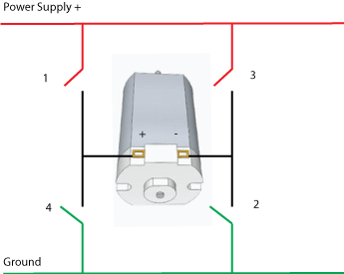
This diagram shows a simplified version of such a circuit. Closing switches 1 and 2 effectively connects the positive rail of the power supply to the + terminal on the motor and ground to the – terminal and the motor runs forwards. Alternatively, closing switches 3 and 4 connects the ground to the + terminal and the positive rail to the – terminal and the motor runs in reverse.
There is a potentially dangerous situation if switches 1 and 4 or 3 and 2 are closed. This would create a short circuit between Power Supply + and Ground which can be very problematic to say the least. Care must be taken when controlling this circuit to ensure that this situation can never happen.
In reality we can’t have four physical on / off switches like this as we need to control the circuit using the GPIO on the Raspberry Pi. There are electronic solutions to this. One possibility is the use of electromagnetic relays to close these “switches”, however the Raspberry Pi is not able to deliver enough power from the GPIO to directly activate such a relay without something having something in-between such as a transistor, which leads us to the second possible solution which is to simply use some transistors as switches.
Transistors as switches.
The transistor is arguably the most important electronic invention ever created. It’s development is responsible for everything from portable music players to the processor used in the Raspberry Pi.
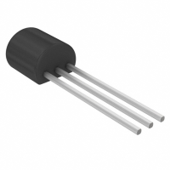
We will be looking at NPN type transistors. This device has three terminals called base, collector and emitter. Connecting a power supply across the collector and emitter makes the transistor have the potential to be used as a switch, at this stage the “internal resistance” of the transistor is extremely high and the “switch” is off. If we apply a current to the transistor base then the internal resistance will drop by a corresponding amount and more power will flow from the collector to the emitter. The transistor is able to vary its internal resistance very quickly, tens of thousands of times per second. (It’s this feature that allows transistors to be used as amplifiers). The amount that the current affects the internal resistance of the transistor is defined by a ratio known as the “DC current gain” and is referred to as “hFE”.
In our case we want to supply a current to the base that will make the internal resistance be zero – just like a closed switch. This is called “Transistor Saturation” and there is an equation which tells us the current we need to apply to the base to make this happen. This equation is :
Base current = IC / hFE
“IC” is the current that will be flowing to the collector. In order to find out what this current is it’s necessary to measure the current that’s drawn by the motor. This means an experiment is needed! For this you will need your motorised base (in my case it’s the modified Big Trak), a power supply (some batteries) and a multimeter. If you don’t own a multimeter yet, they are essential piece of kit for anyone who is involved in electronics and allow you take a wide range of measurements including voltage, current, resistance, capacitance and hFE. It is possible obtain a good multimeter for under ten pounds from a variety of retailers.
DC motors draw different currents under different conditions. If a motor is “free-wheeling” then the motor will draw a comparatively small current. Alternatively a “stalled” motor (a motor that is prevented it from turning) it will draw an extremely high current. The harder we make a motor work, the more current it will draw. In our case we want to measure the current the motors draw when our robotic base is trundling along the floor. One way to accurately obtain this measurement is to make the base move on the ground and measure the current that is being drawn. Here is the method I used with my Big Trak:
Connect the multimeter in series between the battery/power supply and one of the motors in the Big Trak.

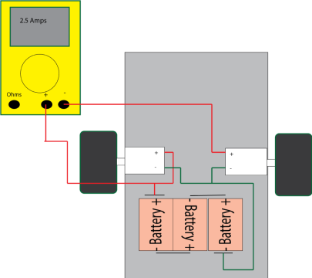
The second motor must also be connected to the power supply and active otherwise only one motor will try to drive the whole Big Trak which will result in an inaccurate measurement. However we only need to measure the current drawn by one of these two identical motors.
Add some weight to the Big Trak which approximates the expected overall weight of the finished robot. In the case of the Skutter this included adding the robot arm.
Complete the circuit between the batteries and motor, including the multimeter in series as shown. As the Big Trak rolls along the floor, take a measurement of the current which is being drawn. Under the expected load for the Skutter using this method, one of the two big trak motors will draw a current of 2.5 Amps. When the motor was stalled – prevented from moving, the current drawn was 20 Amps.
Choosing the right transistor
Each transistor will have a current at the collector; this current is the same as the current that’s drawn by the motors. This was 2.5 Amps for the Big Trak (but obviously would be different if you are basing your robot on different motors.) We now need to find some transistors that will behave like switches when they are passing this current.
Consider again the transistor saturation equation: Base current = Collector Current / hFE. Two of the values in this equation are now known. We have 2.5 A for Collector Current and we know that any GPIO pin on a Raspberry Pi is able to deliver a maximum of 15 mA (or 0.015 Amps). We need to find out a minimum value for hFE (current gain) using these two values and this can be obtained by rearranging the equation to hFE = Collector Current / Base Current.
For a transistor to be able to switch a Big Trak motor using the GPIO as the trigger this would be:
hFE = 2.5 / 0.015.
Therefore a transistor with a current gain of at least 167 is needed. Furthermore the transistor must be able to handle 2.5 Amps. For very short time periods the circuit we design must also be able to handle up to as much 20 Amps as the motors can draw this much if they are stalled.
One such transistor is a BCU81 which can handle a continuous current of 3 Amps and has a minimum current gain (hFE) of 210.

A Transistor Motor Driver Circuit
The BCU81 Transistor has a current gain of 210. This means that we only need to supply 12 mA from the GPIO. (Base Current = Collector Current / hFE.) (2.5 / 210 = 0.012)
We can use a current limiting resistor in series with the GPIO outputs to make sure that we are only taking 12 mA. To work out the value for this we use Ohms law: Resistance = Voltage / Current.
The GPIO uses 3.3 Volts (referred to as 3v3) so we can use these values to work out the necessary values for our current limiting resistors: 3.3 / 0.012 = 275 Ohms. We would usually need to factor in a voltage drop in this equation but as a transistor has no appreciable voltage drop when at saturation this isn’t necessary and this particular calculation is very simple.
A commonly available resistor value is 270 Ohms. Using this value instead of 275 Ohms has negligible effect on the GPIO current, so for simplicity it is acceptable to use this resistor.
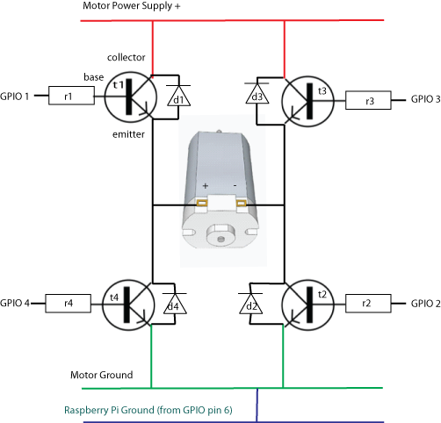
This is then a working H bridge motor controller circuit for a Raspberry Pi (There is a health warning that comes with it however, please take note of it at the end of the article). There are four diodes added which are orientated in the opposite direction to the flow of current. This is because a DC motor will also generate an electric current, especially as it is being switched off. This is referred to as “fly back current” and it can be high enough to damage the transistors. Having these reverse biased diodes allows any fly back current to escape safely. You can use this circuit if you are using the same model of Big Trak or if you are using a base that uses different motors, adapt the calculations described earlier and find some suitable resistors and transistors.
An important aspect of this circuit is that the ground of the Raspberry Pi is being shared with the ground from the motor power supply. Having a “common ground” like this means that we can have two separate devices, which are powered by two separate power supplies and still working together electronically.
Finally, we can see that in order to drive the motor forwards we need to turn on GPIO 1 and GPIO 2. To reverse the motor we need to turn on GPIO 3 and GPIO 4. The “In Control” articles of the MagPi contain the information about the programming that’s required to do this and if you are constructing this circuit then you may consider designing this program to be your challenge for next month!
If, like me, you are making a differential robot that uses two motors then you will need two of these circuits, one for each motor. That means that in total you are using up eight of your GPIOs which doesn’t leave a lot of inputs and outputs free for the rest of the robot.
Health Warning! At any one time that both motors are being driven, there will be four GPIO pins delivering 12 mA each. That means a total of 48 mA. The maximum total current deliverable from the whole GPIO header at any one time is 51 mA. Directly driving a H bridge form the GPIO pins like this is very close to the absolute safe limits of operation. In order to use any other output it would first be necessary to set all the H bridge GPIOs low to safely allow current to be delivered elsewhere. Finally – as the current the GPIO is able to deliver is relatively low we have had to look for a transistor with a high hFE that can also handle 3 Amps. Such transistors are quite expensive options!
In the next article I am going to describe a way of vastly increasing the number of GPIOs on your Raspberry Pi using an inexpensive chip called the MCP23008 and the I²C bus. This method will solve the limited current problem and will allow your robot to have many more inputs and outputs as well as allow us to use much cheaper, lower hFE value transistors in our circuit.

